Not Your Mother’s Soap Opera
Additional viewing Material, Spring 2024

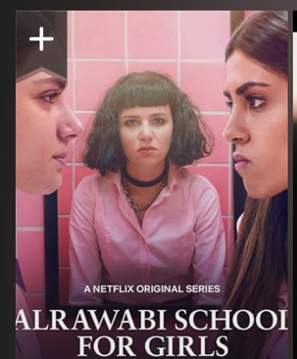

Trailer https://www.youtube.com/watch?v=xxKnhO7Nq7I
https://www.newyorker.com/culture/culture-desk/the-netflix-teen-drama-that-goes-deeper-into-the-arab-patriarchy
https://en.wikipedia.org/wiki/AlRawabi_School_for_Girls
https://www.imdb.com/title/tt10183912/reviews

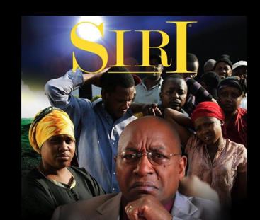
Siri

Trailer Youtube https://www.youtube.com/playlist?list=PLY1of6Zz3K5--7gj04jNB8JFTJo96hIZF
https://www.business-humanrights.org/en/latest-news/kenya-to-investigate-sex-for-work-exposed-in-bbc-tea-documentary/
https://www.youtube.com/watch?v=254OZk4_cF0; https://www.youtube.com/watch?v=ZxsxziCgnsY
https://mpasho.co.ke/entertainment/2023-11-27-kenyan-drama-series-siri-debuts-on-netflix/

Cigarette Girl
Trailer https://www.youtube.com/watch?v=ejRQzHh8gLI
https://www.imdb.com/title/tt21279114/reviews;
https://decider.com/2023/11/03/cigarette-girl-gadis-kretek-netflix-review/
https://decider.com/2023/11/03/cigarette-girl-gadis-kretek-netflix-review/

Empresses in the Palace
Official Trailer https://www.youtube.com/watch?v=b7CgbcQXDXA
https://en.wikipedia.org/wiki/Empresses_in_the_Palace
One review: “This series is freaking gangster! Don't expect any ridiculous love drama. This TV show would've made Machiavelli proud.”

