**Growth Cancels Climate Solutions**

*“When it comes to climate change, winning slowly is the same as losing.”*

*—Bill McKibben*

Efforts to reduce greenhouse gas emissions (GHG) so far have concentrated almost exclusively on technology solutions: renewable energy, improving energy efficiency, and sequestering carbon. So far, despite impressive innovation and progress on these technological fixes, fossil fuel use continues to climb (Figure 1).

**Figure 1: Fossil fuel use growth**

The fundamental problem is that humanity has outgrown the scale of the planet. Technology solutions while growth continues will eventually run into planetary limits. Tearing up more of the earth to mine lithium, cobalt, etc. for solar panels, and to cover farmland with wind turbines further destroys our only home planet.

Behavioral approaches—reversing population growth and economic growth—could be easier, faster, less costly, and complementary to technological solutions. Cutting emissions via technology will become more feasible and affordable If demand for energy falls.

**A quick review of greenhouse science**

Cumulative concentrations of greenhouse gasses in the atmosphere regulate Earth’s climate. With no greenhouse gasses (chiefly water vapor, CO2, and methane) the earth would be “snowball earth,” too cold for human life and crops. With five times present concentrations of greenhouse gasses, high temperatures would make our enzyme systems shut down and we would die. Pools of carbon dioxide that could be released by burning fossil fuels, releases from peat and permafrost, soils, and plants, as well as the more than 30,000 gigatonnes of carbon dioxide dissolved in oceans could, if released, take the planet to temperatures incompatible with human survival. After tipping points are passed, greenhouse gas releases become unstoppable.

Atmospheric CO2 concentrations have increased from 280 ppm when first measured in the nineteenth century to 415.5 ppm in January 2021.[1] World average temperatures have risen 1.3 degrees C (2.2 degrees Fahrenheit). The annual sawtooth pattern in Figure 2 shows seasonal drawdown of CO2 by plants during the northern summer, due to the larger land areas in the northern hemisphere.

**Figure 2: The Keeling Curve**

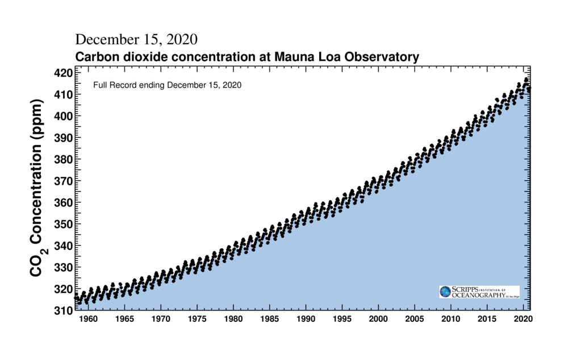

https://www.co2.earth/monthly-co2[2]

CO2 concentrations have never risen so quickly in the four-billion-year history of life on Earth. Past less rapid increases in CO2 due to volcanic activity and burning of coal beds led to “extinction events” that in worst cases wiped out over 90% of all species then living.

Increases in cumulative atmospheric GHG concentration comes from fossil fuel burning and land clearing. About 60% of current emissions stay in the air while the rest dissolve in oceans or are taken up by green plants. Table 1 shows how much has been added since 1970. Once in the atmosphere, CO2 will remain for thousands of years. The longer GHGs continue to accumulate, the faster new emissions reductions must be to avoid unacceptable outcomes.

**Table 1: Gigatonnes of CO2 annual and cumulative emissions**

|  |  |  |  |  |  |  |
| --- | --- | --- | --- | --- | --- | --- |
|  | Annual and Cumulative CO2 Emissions Since 1970 | | | | |  |
|  | 1970 | 1980 | 1990 | 2000 | 2010 | 2020 |
| Emissions | 15.4 | 19.4 | 22.2 | 24.9 | 33.4 | 37.5 |
| Cumulative | 15.4 | 176 | 357 | 613 | 907 | 1232 |

The UN’s Intergovernmental Panel on Climate Change (IPCC, 2017**)** calls for reducing carbon emissions substantially by 2030 and to zero by 2050. Figure 3 shows the increasing steepness of GHG reductions required as cumulative emissions continue to rise. So far, there are no policies in place that would result in the increasingly steep declines called for in Figure 3.

**Figure 3**

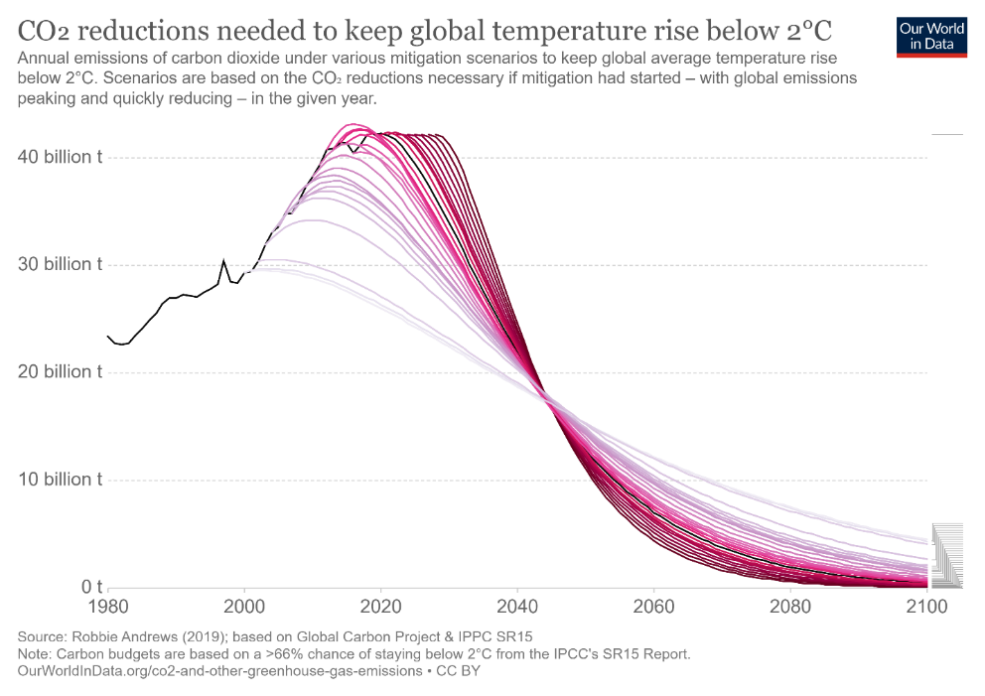

The world economy, which is 85% dependent on fossil fuels for energy, can’t be retooled for sustainable energy overnight. Poor countries hope to increase their standards of living by *increasing* energy use. Meanwhile, most people in rich countries, even those who are aware of the emissions problem, are not giving up flying, driving, heating homes, hot showers, or even recreational fossil fuel uses such as travel, auto racing, and boating[3].

Even now, after decades of climate warnings, much of world energy demand growth is being met by increasing use of fossil fuels. According to the International Energy Agency, two-thirds of new energy investment in 2019 was for fossil fuel development, only one-third for renewable solar and wind energy.[4]

The U.S. Energy Information Administration (EIA) projects a 50% growth in world energy consumption by 2050.

**Figure 4**

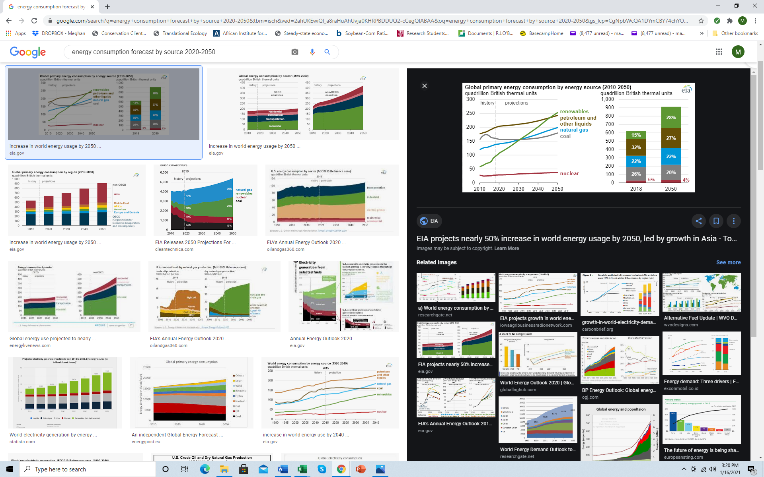

<https://www.eia.gov/todayinenergy/detail.php?id=41433>

U.S. Energy Information Administration

Many practical difficulties will slow the transition to renewable energy, including fossil-fuel subsidies and lack of “feed-in tariffs” that allow solar power to be sold to the grid at favorable prices. The world lacks battery technology and or other ways to store energy to cope with the intermittency of solar and wind power.

Carbon sequestration has not yet proven feasible with current energy prices and faces daunting technological problems. “Geoengineering” solutions like fertilizing the oceans or dispersing sulfur aerosols in the stratosphere to reflect sunlight into space pose risks of unforeseen consequences.

Here are a few ballpark numbers to give a sense of the economic challenge.[5]

* + World GDP: $85 trillion (World Bank, 2010 U.S.$)
  + World physical capital: $520 trillion (Korn Ferry number from a *Forbes* article)
  + World annual capital investment: $23 trillion (World Bank)
  + Climate disasters cost in 2020: $210 billion (NOAA, *Scientific American*)
  + Cost to shift to non-carbon economy by 2050: $125 trillion (Morgan Stanley, et al.; Jacobson, et al.)
  + On the bright side, renewable energy would yield significant savings on fossil fuel development and supply costs.

With $23 trillion a year of investment, it would take 22.6 years (520/23=22.6) to replace the world’s physical capital stocks, even without allowing for growth. Shifting to a non-carbon economy appears to require diverting a quarter of world capital investment, say $5 trillion annually, for 25 years. Which suggests we need over eight times more investment in renewables compared to the 2019 renewable energy effort.

Putting trillions into de-carbonizing the economy means trillions will not be available for other projects. Delays are rapidly transforming “difficult” to “impossible.”

The lack of a price on carbon emissions is probably the biggest “market failure” in history. To ramp up investment in renewables eightfold and put a quarter of the world’s other investment needs on hold for 25 years or more will require major policy initiatives. Most importantly, a price on carbon, a global carbon tax. And more R&D and incentives to build solar.

Depressions, wars, plagues, or climate disasters would cut the amount of capital available for installing renewable energy. With many projects there are delays and cost overruns. Shortages of key materials, such as minerals needed for batteries could delay the transition to renewable energy.

Twenty-five-year doubling time (3% GDP growth) means four doublings per century or 16 times greater output. So far, efforts to decarbonize have been on a treadmill—forward progress on solar and wind offset by economic and population growth that drives energy demand upwards. Emissions are still rising.

Reversing population growth and economic growth would be labelled desperate measures from a conventional pro-growth perspective. From the standpoint of environmentalists and those concerned about quality of life and preserving ecosystem health and species diversity, ending growth is long overdue and highly beneficial for many reasons in addition to helping avoid climate change disasters.

## The Kaya Identity: A simple model for exploring emissions policy alternatives

In 1990 Koichi Kaya, a Japanese engineer, proposed an equation that reveals the relative contributions of technological and behavioral components that drive greenhouse emissions.

**Kaya’s Identity**: C = C/E * E/Y * Y/P * P

Where:

C = Greenhouse emissions,[6]

E = Energy,

Y = Economic output (GDP),

P = Population

“Carbon intensity” of energy production, C/E, is lower for renewables like solar panels,[7] higher for coal and tar sands oil.

E/Y means energy (E) used per dollar of economic output or GDP (Y). Lower E/Y means better energy efficiency. Y/P is economic output (gross domestic product, GDP) divided by population, otherwise known as average per-capita income. Population (P) has been growing throughout human history, except for brief dips due to plagues.

We can look up historical trends and current numbers for C, E, Y, and P, the variables in the Kaya equation.[8] Assumptions about future rates of change in the four right-hand-side Kaya terms (C/E, E/Y, Y/P and P) can be multiplied to generate future GHG emissions projections.

Table 4 shows 2000 and 2019 levels of each Kaya equation variable from World Bank, UN, and IEA data sources.[9] It also shows change and percent of change from 2000-2019. The right-hand two columns of Table 4 compare compound annual growth rates from 2000-2010 versus 2009-2019. GHG emissions grew by 3% annually during the new century’s first decade and by 1.8%/year, during the second decade.

After falling by 7% during 2020 due to the pandemic shutdowns, emissions resumed their upwards trend during 2022 and 2023. “Despite decades of warnings from the scientific community, thousands of pages of reports and dozens of climate conferences, we are still heading in the wrong direction,” said WMO Secretary-General Prof. Petteri Taalas.[10]

**Table 2: Kaya terms compound average annual rates of growth/decrease 2000-2019**



Source: World Bank, World Development Indicators, IEA

Over the twenty-first century’s first two decades, population and economic growth more than offset gains in energy efficiency (total E/Y change, -22%), and a slight improvement in carbon intensity of energy production (total C/E change, -4%). These gains were swamped by 35% growth in incomes (Y/P) and 26% growth in population (P) as the world economy grew by 70%. Growth drove annual CO2 emissions 51% higher in 2019 than in 2000. The required decline in emissions towards zero by 2050 has been slow to get started, except for temporary pauses in recession and pandemic years.

These numbers do not include increased methane releases from fracking, record nitrous oxide emissions, and other GHG emissions. Feedback effects of increased use energy for air conditioning, wildfires, forest clearing, melting permafrost, seabed methane volatilization, and changing albedo as arctic and glacial ice melt indicate approaching tipping points. Spaceship Earth’s life support systems are hurtling towards danger zones.

**Three future emissions scenarios**

The world’s bias towards growth makes a “green growth” solution more appealing than downsizing the human enterprise. It is tempting to assume that building solar panels can solve the emissions problem.

Ecological economist Herman Daly tells us the underlying problem is planetary limits to growth. Trying to grow our way out of scarcity—in this case, scarcity of planetary capacity to store atmospheric carbon—will make the problem worse or impossible to solve in the long run. The key insight from the 1972 *Limits to Growth* world model was that with massive exponential growth, if one limit can be avoided another will soon appear. Technologies that allow humanity to bypass one limit increase damage to the overall biosphere.

Table 3 projects annual and cumulative emissions under three hypothetical scenarios: 1) Business as usual, 2) Faster technology installation, and 3) Adding reversing population growth and slowing economic growth to the agenda in addition to ramping up renewable energy technology and efficiency investments.

**The Business as Usual (BAU) scenario**. Rates of change of all the Kaya terms, C/E, E/Y, Y/P and P in the BAU are projected at their rates from 2009-2019. Economic and population growth at 1.8% and 1.16% respectively more than offset gains in renewable energy (C/E, -0.5%/year) and energy efficiency (E/Y, -1.4%/year). Annual carbon emissions continue to rise, more than doubling to 83.4 gigatonnes/year by the end of the century with cumulative CO2 emissions totaling 4713 gigatonnes. This scenario heads the world towards catastrophe with weather extremes that would be fatal to humans and to most other species on the planet.

**The Technology Policies (carbon tax by 2023**) scenario does better, with optimistic assumptions about the economic, political, and technological feasibility of accelerating installation of renewable energy sources. Rate of decline of C/E (carbon intensity) increases fivefold from -.5% to -2.5%/year. If percentage of decline is proportional to investment in renewables, that would mean increasing from $600 billion, the 2019 figure, to $3 trillion per year.[11] This scenario assumes that the rate of annual energy efficiency gains doubles with E/Y decline rising from -1.4% to -2.8%/year. Ramping up energy investment this much probably implies passage of a global carbon tax.

This technology scenario requires massive investments to continue indefinitely as population and economic growth continue to push up energy demand. Under this scenario, annual carbon emissions fall to 15% of 2019 levels by the end of the century. But by then cumulative carbon additions total 1480 gigatonnes, likely to result in 3-4 degrees C average temperature rise. A catastrophic scenario, but not quite extinction for humans. Extinction for many other species and poverty, famine, and lower quality of life for billions of humans. Mass migration from the tropics and loss of sea level cities.

**The All-Hands-on-Deck** scenario adds degrowth policies to the technology solutions. Beginning in 2023, world economic growth slows from 1.8% to 0.8% per year. Population growth slows gradually by -0.4%/year. Under these assumptions, world per- capita incomes nearly double from $11,000 to $21,700 by 2100. World population peaks at midcentury near 9.4 billion, before falling back to 5.7 billion by 2100, making world population in 2100 approximately equal to world population in 1995. This scenario, which assumes the same radical ramping up of technology solutions as in the previous scenario, reduces emissions to less than 1 gigatonne by 2100. Cumulative emissions over the remainder of the century total 1,031 gigatonnes. About another 2 degrees C, or a total of 3 degrees C from pre-industrial levels.

**Table 2: Three emissions scenarios—BAU, technology, and technology plus ending growth**



Unfortunately, accomplishing major changes in public opinion and enacting radical anti-growth and carbon tax policies have been kneecapped by fossil fuel companies’ promotion of science denial.

Having littered the U.S.A. with 130,000 abandoned oil and gas wells, humanity will proceed to destroy land in the Congo to get hold of cobalt for “green growth.” Continuing growth on a finite world is already causing permanent damage to the community of life and changing environmental conditions that support human life. So far, 35 years after James Hansen warned Congress the world is warming, emissions continue to rise.

New technologies are being invented to sequester carbon. But these efforts are uneconomical and miniscule compared to emissions. It would be wonderful if a sequestration technofix shows up, but I wouldn’t bet the planet or my grandson’s life on it.

At present, ending income or population growth are “politically impossible.” But the same objection applies to carbon pricing that would incentivize massive investment in renewable energy technology, efficiency gains, and carbon sequestration technologies. The smart money might bet on collapse rather than coping.

But what is politically possible changes over time. Eventually it may become clear that only strong and comprehensive climate stabilizing measures will keep Earth habitable as heat deaths rise, crops fail, and climate refugees flood across borders.

We’ll have to decarbonize faster because we delayed starting soon enough. A comprehensive approach including both technology and degrowth has already become the only feasible strategy to stay below 2o C.

**Synergies would speed the transition**

Degrowth would allow an increased proportion of reduced energy demand to be met by existing cleaner energy sources such as solar, hydro, and nuclear power. Since 15-20% of energy demand is currently met by renewable, sustainable energy, cutting demand to 20% of current levels would allow non-carbon emitting sources to supply near 100% of energy needs without constructing a single additional windmill.

In addition, shrinking population means less need for new housing, roads, and less urban sprawl (shorter commutes, less oil burned). Reducing demand growth would free up capital and materials for investment in efficiency and renewable energy technologies. Therefore, reducing Y/P and P could speed reductions of C/E and E/Y by freeing investment capital and scarce supplies.

Reversing population growth offers opportunities for sequestration of carbon in soils and forests through ecosystem recovery on a less crowded planet. Expanding populations clear forests; declining populations can give land back to nature.

**Time Lags for implementation**

There are differing time lags or delays in implementation of changes in the four Kaya terms. Reducing C/E by installing renewable solar energy sources and inventing ways to make fertilizer and cement and to fly airplanes without fossil fuels will take decades. Increasing energy efficiency also requires long process of retrofitting buildings and replacing long-lived capital equipment, including power generating stations, factories, fleets of ships, cars, aircraft, trucks, farm equipment, and so on.

Cutting economic growth, on the other hand, could be done overnight by intentionally restrictive Federal Reserve policy or a carbon tax used to cut deficit spending and reduce government debt. Anti-growth monetary and fiscal policies could put the world economy into recession within weeks. Ecological economist Herman Daly suggested tightening fractional reservebanking regulations[12] and other anti-growth, anti-consumption measures.[13] These measures would obviously be painful, but measures to improve distribution and give economic security to the poor could make sacrifices tolerable. Cutting output and incomes by mandating a three or four-day workweek allows trading income for more leisure.

In recent decades there have been about 140 million births and sixty million deaths, resulting in 80 million more of us each year, a billion added to world population every 12 years. In 2021 easing of population momentum as populations age, plus falling fertility rates decreased growth to 67 million. Reversing population growth has proven to be a feasible objective.

Falling fertility rates slow growth immediately, but population decline doesn’t start until half a century later when “population momentum” reverses as populations age. The right to reproduce is a fundamental human right. Therefore, Table 3 assumes slow decline in population growth rates to allow time to persuade individuals and societies to evolve smaller family size norms.

World average birth rates fell by one child/woman (from about 5 to 4) in the 1970-1980 decade. With enough attention and funding, birth rates can fall quickly. The world’s “natural experiment” where countries that accomplished fertility transitions also got richer and longer lived while high fertility countries remained poor has demonstrated the value of the “demographic dividend” from lower birthrates.

It should be possible to humanely reverse population growth with a strong global effort to help the poorest countries adopt the 1 or 2 children family size norms of the richest countries. Access to affordable modern contraception and legal, affordable abortion would go far, since nearly half of all pregnancies are unintended. Family planning campaigns selling the message “two is enough” were effective in helping the Asian Tiger economies rapidly improve health and economic outcomes. Once couples can choose how many children they have, in modern economies they tend to freely choose less than two.

## The closing window

The fossil-fuel industry stands to lose trillions of dollars as fossil fuel reserves become “stranded assets” that must be left in the ground.[14]

A 2013 *Scientific American* article reported that “In all, 140 foundations funneled $558 million to almost 100 climate denial organizations from 2003 to 2010.” These “merchants of doubt” use effective propaganda tactics, including repeating baldfaced lies time and again. When climate change became undeniable, misleading advertising campaigns morphed to touting “clean coal” and “green natural gas,” the implication being “Don’t worry, we’ve got this under control.” They don’t. They are still blowing smoke.

## Self-reinforcing feedback effects increase GHG emissions

The movie *Dr. Strangelove* developed the premise of a “doomsday machine” which if accidentally set off would wipe out mankind by making the planet uninhabitable.

Self-reinforcing positive feedback processes accelerate *carbon release* (Cr) and reduce *carbon sequestration* (Cs) as global temperature rises. Equation 2 offers an augmented Kaya Identity with Cr and Cs variables added to represent changes in atmospheric concentrations of GHG from the environment.

Equation 2: C = C/E * E/Y * Y/P * P + (Cr-Cs)

Studies of past extinction events that wiped out over 90% of the species on earth conclude that the most plausible cause was release of large amounts of carbon by volcanoes and burning coal beds that triggered rapid global warming and ocean acidification.[15]

NASA scientist James Hansen has expressed fears of a runaway “Venus Syndrome.” Venus’ surface temperature averages 450 C. Water boils at 100 C., so if Venus had oceans they boiled away. Unstoppable feedback loops of rising net emissions (Cr-Cs) could continue to warm Earth even after human GHG emissions fall to zero.

For 4 billion years, Earth has supported a co-evolved, self-regulating community of interdependent species that contribute to the temperature regulation of the planet. Feedback amplification of warming due to rising cumulative atmospheric carbon could, in worst-case scenarios, “break” the Earth’s thermostat.

It is hypocritical and dishonest that people who claim to be “techno-optimists” counting on scientists to solve climate problems then choose to ignore scientists’ warnings that we need to stop burning fossil fuels and stop population growth.

“Solutions” that come too late to prevent major GHG cumulation in the atmosphere from Earth’s large carbon pools currently sequestered safely in oceans, fossil fuels, biomass, permafrost, seabed methane, and so on, will be futile if environmental feedback processes continue to amplify releases. After tipping points are reached, carbon releases might accelerate for thousands of years. That’s what Bill McKibben meant by the epigraph quote, “Winning slowly is losing.”

## We can do this

Reducing population and slowing economic growth are not unthinkable possibilities. Several of the world’s most economically successful countries, including Japan and Germany, already have falling populations due to decades of low birth rates.[16]  People in Japan and Germany are far better off, in part *because* of low fertility rates, when compared to people in high-fertility countries like Nigeria or Haiti. Because crowding and pollution drive up the costs of living and reduce the quality of life, every country would be better off with lower fertility rates.

Few practice “hyper-frugality,” a term referring to a lifestyle that seeks happiness by living simply, avoiding debt, consuming less, and saving more.[17] The virtues of frugality were mainstream nineteenth-century values, but have been undermined and replaced by hyper-consumerism fostered by endless advertising messages.

Research on the psychology of happiness shows that people can live good lives with sufficiency and get little benefit from excessive consumption.[18] Pioneer psychologist Alfred Adler identified “life tasks” as “community, meaningful work, and intimacy.” He did not mention getting rich or owning a bigger house.[19] And see Matthew 19:21[20] and Jesus’ other teachings on wealth as a barrier to salvation.

The cultural and behavioral changes required to solve CO2 emissions could leave us healthier and more connected to nature and each other. We could have more joy, less stress, and more security by reducing consumption and economic growth.

The rich countries caused the climate change problem with their massive burning of fossil fuels. Their task is to cut consumption and to cut low fertility rates even further since each rich child has the emissions impact of a hundred poor children.

Poor countries will feel the greatest impacts of climate change through disruptions of subsistence agriculture, soil losses, forest fires, extinctions, water shortages, sea level rise, etc. These countries have few spare resources for adaptation and survival. Their best chance of coping successfully will be to cut current high fertility rates quickly, an outcome that will help enable more education, rising per-capita incomes, and adequate food supplies, while helping to reverse forest clearing and soil losses. To sequester carbon, we must give land back to nature.

Rapidly developing countries with falling birthrates like the BRICS, will find that following the Western development model based on endless growth and increased burning of fossil fuels leads to social injustices, traffic congestion, and pollution rather than true well-being. These middle-income, rapidly developing countries should try for sufficiency and justice, rather than growth. Bicycles, not cars. Energy infrastructure investments in these fast-growing countries should be 100% in renewables rather than fossil fuels.

## A feasible green future

Instead of political campaigns promising growth and jobs, genuine leaders must convince the public to accept wealth taxes, carbon taxes, cuts to consumption, responsible reproduction, social justice, and sustainability. Instead of saying, “Population growth means we need more jobs,” politicians should more honestly admit that “Too many jobs are wrecking the Earth. We need to cut our numbers *and* cut consumption.” Scarcity caused by growth will not be cured by more growth.

A comprehensive set of greenhouse policies would address all four terms of the Kaya equation, with fertility reduction perhaps the easiest to accomplish and cheapest. Reversing economic growth could be accomplished even more rapidly by anti-growth policies and a global carbon tax.

Falling population and falling consumption would allow greater proportions of energy needs to be met from cleaner energy sources and accelerate gains in energy efficiency. “Voluntary simplicity” would not entail much sacrifice in rich countries, the main carbon emitters, while offering important benefits including less debt, stress reduction, more leisure, and more time for community and family.

If all four Kaya terms head in the right direction, their synergies could transform climate stability from receding fantasy to feasible project.

**References**

Adler, Alfred. Adler Institutes, “Three Life Tasks.” http://www.adlerian.us/tree.htm

Bardi, U. *Extracted: How the Quest for Mineral Wealth is Plundering the Planet.* White River Junction, VT: Chelsea Green Publishing, 2014.

Benedick, R.E. (2000). Human population and environmental stresses in the twenty-first century. Environmental Change and Security Project Report, 6, 5-17.

Bradshaw, C. J., & Brook, B. W. (2014). Human population reduction is not a quick fix for environmental problems. Proceedings of the National Academy of Sciences, 111(46), 16610-16615.

Campbell, M. M., Casterline, J., Castillo, F., Graves, A., Hall, T. L., May, J. F., Perlman, D., Potts, M., Speidel, J. J., Walsh, J., Wehner, M. F., & Zulu, E. M. (2014). Population and climate change: who will the grand convergence leave behind? The Lancet Global Health, 2(5), e253-e254.

CarbonBrief. (2015). Analysis: Developing countries need $3.5 trillion* to implement climate pledges by 2030. Retrieved from http://www.carbonbrief.org/analysis-developing-countries-need-3-5-trillion-to-implement-climate-pledges-by-2030

Cohen, Joel E. (2010) “Population and Climate Change,” Proceedings of the American Philosophical Society, Vol. 154, No. 2, June 2010, pp 158-182.

Cramton, P., MacKay, D. J., Ockenfels, A., & Stoft, S. (Eds.). (2015). Global Carbon Pricing: We Will If You Will. The Price Carbon Project. Retrieved from http://carbon-price.com/wp-content/uploads/Global-Carbon-Pricing-cramton-mackay-okenfels-stoft.pdf

Daily, G. C., Ehrlich, A. H., & Ehrlich, P. R. (1994). Optimum human population size. *Population & Environment,* 15(6), 469-475.

Ehrlich, P., & Holdren, J. (1972). A Bulletin Dialogue on “The Closing Circle,” Critique. One dimensional ecology. *Bulletin of the Atomic Scientists,* 28:16-27.

Gerland, P., Raftery, A. E., Sevčíková, H., Li, N., Gu, D., Spoorenberg, T., Alkema, L., Fosdick, B. K., Chunn, J., Lalic, N., Bay, G., Buettner, T., Heilig, G. K., & Wilmoth, J. (2014). World population stabilization unlikely this century. *Science*, 346(6206), 234-237.

Guillebaud, J. (2016). Voluntary family planning to minimise and mitigate climate change. BMJ, 353, i2102. doi:10.1136/bmj.i2102

Hansen, James. *Storms of My Grandchildren*. New York: Bloomsbury Press, 2009.

Harte, J. (2007). Human population as a dynamic factor in environmental degradation. *Population and Environment*, 28(4-5), 223-236.

Holdren, J. P. (1991). Population and the energy problem. *Population and Environment*, 12(3), 231 -255.

Intergovernmental Panel on Climate Change (IPCC). (2014a, April 13). IPCC: Greenhouse gas emissions accelerate despite reduction efforts [Press release]. Retrieved from http://www.ipcc.ch/pdf/ar5/pr_wg3/20140413_pr_pc_wg3_en.pdf

Intergovernmental Panel on Climate Change (IPCC). (2014b). Climate Change 2014: Impacts, Adaptation, and Vulnerability. Summary for Policymakers. Retrieved from https://www.ipcc.ch/pdf/assessment-report/ar5/wg3/ipcc_wg3_ar5_summary-for-policymakers.pdf

Kaya, Y. (1990). Impact of Carbon Dioxide Emission Control on GNP Growth: Interpretation of Proposed Scenarios. Paper presented to the IPCC Energy and Industry Subgroup, Response Strategies Working Group, Paris.

Kummerow, Max, unpublished 2015. “Divergent African-European fertility rates: Root cause of migration.”

Mill, John Stuart, Principles of Political Economy with Some of their Applications to Social Philosophy, Book IV, Chapter VI of the Stationary State. London: Longmans, Green and Co., first published 1848, Seventh Edition 1909.

National Resources Defense Council (NRDC). (2015). Issue Brief: The Paris Agreement on Climate Change (Report no. IB: 15-11-Y). Retrieved from https://www.nrdc.org/sites/default/files/paris-climate-agreement-IB.pdf

O’Neill, B. C., Dalton, M., Fuchs, R., Jiang, L., Pachauri, S., & Zigova, K. (2010). Global demographic trends and future carbon emissions. Proceedings of the National Academy of Sciences, 107(41), 17521-17526.

Olivier, J. G., Janssens-Maenhout, G., Muntean, M., Peters, J. A. (2015). Trends in global CO2 emissions: 2015 report (Report no. 1803). Netherlands: PBL Netherlands Environmental Assessment Agency. Retrieved from http://www.pbl.nl/en/publications/trends-in-global-co2-emissions-2015-report

Oreske, Naomi, & Conway, Erik. *Merchants of Doubt: How a Handful of Scientists Obscured the Truth on Issues from Tobacco Smoke to Global Warming.* New York: Bloomsbury Publishing, 2011.

Pacala, S., & Socolow, R. (2004). Stabilization wedges: solving the climate problem for the next 50 years with current technologies. *Science,* 305(5686), 968-972.

Rogelj, J., D. Shindell, K. Jiang, S. Fifita, P. Forster, V. Ginzburg, C. Handa, H. Kheshgi, S. Kobayashi, E. Kriegler, L. Mundaca, R. Séférian, and M.V. Vilariño, 2018: *Mitigation Pathways Compatible with 1.5°C in the Context of Sustainable Development. In: Global Warming of 1.5°C. An IPCC Special Report on the impacts of global warming of 1.5°C above pre-industrial levels and related global greenhouse gas emission pathways, in the context of strengthening the global*

*response to the threat of climate change, sustainable development, and efforts to eradicate poverty [Masson-Delmotte,* V., P. Zhai, H.-O. Pörtner, D. Roberts, J. Skea, P.R. Shukla, A. Pirani, W. Moufouma-Okia, C. Péan, R. Pidcock, S. Connors,J.B.R. Matthews, Y. Chen, X. Zhou, M.I. Gomis, E. Lonnoy, T. Maycock, M. Tignor, and T. Waterfield (eds.)]

Simon, Julian. *The Ultimate Resource 2*. Princeton, NJ: Princeton University Press, 1996.

Smil, Vaclav. *Harvesting the Biosphere: What We Have Taken from Nature*. Cambridge, MA: MIT Press, 2013.

Tuchman, Barbara. *The March of Folly: From Troy to Vietnam*. New York: Random House, 1985.

United Nations Framework Convention on Climate Change (UNFCC). (2015). The Paris Agreement. Retrieved from http://unfccc.int/paris_agreement/items/9485.php

trillionthtonne.org. (2016). Retrieved from http://trillionthtonne.org/

1. https://www.esrl.noaa.gov/gmd/ccgg/trends/
2. The sawtooth pattern in atmospheric CO2 concentration shows the Earth “breathing.” During the northern summer, plants remove CO2 and emit oxygen on the larger Northern Hemisphere land masses. During winter, when trees drop their leaves, carbon concentrations rise again, each year a little higher.
3. Mea Culpa. My own unwillingness to sacrifice my energy-profligate American lifestyle worries me as much as any other fact. I think the solution will be found in policies we reluctantly impose on each other, such as a global carbon tax, rather than individual behavior changes or sacrifices.
4. Increasingly as major oil fields and coal beds are depleted, larger investments in fossil fuel supply become necessary to replace fossil fuels used up. Oil, coal ,and gas are non-renewable resources. The new technology of fracking requires continued new investment to continue supply at current levels because pressures quickly drop in fracked wells.
5. Sources for these approximate dollar estimates are the World Bank and International Energy Agency and the U.S. Energy Information Administration. There may be some inconsistency in the units, but I believe these figures are current U.S. dollars. Asset valuations, of course, vary with market conditions. These are all ballpark numbers.
6. Greenhouse emissions consist of several gasses plus black soot. All can be converted to their CO2 equivalent effect on Earth’s energy balance. I use C here as shorthand for all greenhouse gasses.
7. The EROI (energy return on investment) gives a clue to how renewable energy assets contribute to GHG emissions. Assuming the renewables are built and transported using fossil fuel energy, they cause emissions up front, then produce energy with few emissions over their working life. EROI estimates vary but may fall in the 10 to 20 range (this from papers cited by a discussion group of European climate scientists who debated EROI of renewables). “Renewable” energy, initially, will contribute fossil fuel emissions about equal to 5-10% of its lifetime energy production. I’m taking the long way around here to avoid having to ask, “How much fossil fuel energy does it take to produce and install a windmill or solar panel?”
8. The Kaya equation is a mathematical “identity.” E, Y, and P appear in both numerator and denominator and so cancel out on the right-hand side, leaving C = C. An identity is an equation that is true by definition. Environmentalists will recognize the Kaya equation as a quantitative example of the Holdren-Ehrlich I=PAT equation where environmental impact (I) equals population times affluence times technology.
9. x <http://data.worldbank.org/products/wdi> Different sources report different values for these variables due to differing data collection methods and other measurement issues. Two conversions to be aware of are CO2 versus carbon (the former weighing 3.66 times as much per mole). And metric tonnes (1000 kg) versus short tons (2000 lbs.). Another source of confusion is whether other GHG contributions to climate change are factored into the emissions figures, often by calculating equivalent CO2 emissions. This is further complicated by the varying removal rates of GHGs. Methane natural gas, CH4) is a more powerful trapper of heat than CO2, but oxidizes to CO2 by combining with atmospheric oxygen.
10. <https://public.wmo.int/en/media/press-release/greenhouse-gas-concentrations-hit-record-high-again>
11. Jacobson, Mark, et al. 2017. “100% Clean and Renewable Wind, Water, and Sunlight All-Sector Energy Roadmaps for 139 Countries of the World,” Mark Z. Jacobson, Mark A. Delucchi, Zack A.F. Bauer, Jingfan Wang, Eric Weiner, Alexander S. Yachanin. Jacobson estimated 50 TW of new installed wind, water and solar capacity could meet world energy demand, and cost $125 trillion in renewable energy investment with a 42% reduction in world energy demand. (p. 17). Other estimates range higher and costs and feasibility are disputed. Moreover, this study covered 139 countries, thereby omitting about 60 (presumably small) countries. Jacobson assumes a net decrease in energy demand relative to business as usual (which involved demand growth) due to efficiencies of WWS power compared to combustion of fossil fuels. These numbers, as I use them, are no better than the “back of a napkin” preliminary feasibility estimates that might lead to further study of a project. If the world did ramp up investment fivefold to $3 trillion a year, about twice total current energy investment, that would mean, in 2017 dollars, about 30 trillion per decade. That’s about the right order of magnitude to accomplish a $124 trillion energy transition by mid-century. <https://web.stanford.edu/group/efmh/jacobson/Articles/I/CountriesWWS.pdf>
12. Banks stimulate economic activity by lending, which creates money, which in turn creates economic activity—new business investments, consumption, new buildings, etc. How much banks can lend is regulated by “reserve requirements.” Oversimplifying to explain the essence of a complex regulatory regime, at present, banks can lend roughly $20 for each dollar of their net worth or capital. So, their reserves equal about 5% of maximum lending. Doubling the reserve requirement to 10% would halve lending and put the economy in recession and interest rates up. Which in the current circumstances would be a good idea. To make this degrowth morally and politically acceptable, government would also have to strengthen “safety nets” by providing stronger unemployment benefits and other forms of income support for the poor.
13. Limiting advertising would be a personal favorite. Maybe one minute per hour of ads instead of 14 minutes. Public service announcements praising frugality, simple lifestyles, banjo playing, and bicycles.
14. xi <http://www.rollingstone.com/politics/news/global-warmings-terrifying-new-math-20120719>. This link takes you to an article by Bill McKibben where he points out the huge economic stakes in carbon pricing.
15. *THE GREAT EXTINCTIONS: What Causes Them and How They Shape Life*. Norman MacLeod. Richmond Hill, Ontario: Firefly Books, 2015. The worst of five past major extinction events nearly ended life on Earth before the age of dinosaurs.
16. xix <http://www.ipss.go.jp/site-ad/index_english/esuikei/sh6.html> Japan’s demographers project a drop to about 1/3 of peak population in 2005 at 128 million to 42 million (medium fertility assumption) by 2110. National Institute of Population and Social Security Research in Japan (IPSS).
17. My son claims to enjoy a hyper-frugal lifestyle and finds joy in his own mind and friendships.
18. xxiii <http://www.huffingtonpost.com/news/happiness-research/> Popular summary of some of the research.
19. xxiv <http://www.adlerian.us/tree.htm>
20. “If you would be perfect, go, sell what you possess and give to the poor, and you will have treasure in heaven.”