How to Register Online for OLLI Courses

- Go to https://reg138.imperisoft.com/OlliIllinois/search/registration.aspx
- Log in to your account.
- Follow step-by-step instructions on the form.

- If you have any questions about your balance, please select the “Pay Later” option. Your registration will still be entered, and we can process your payment at a later date, after your issue is resolved.
- Your registration is complete, and you will receive an email confirmation with a summary of your registration.

Frequently Asked Questions

How do I register for courses?
1. Online: Please follow the step-by-step online registration instructions that can be found on the form. The preferred way to register is online, using your member account. This will give you the fastest real-time access to courses.
2. By phone or email: After 10:00 a.m. on the first day of registration, you may send an email to olli@illinois.edu or phone us at (217) 244-9141 or with your course preferences. Your registration is complete when you receive email confirmation.

Where do I log into my account?
The sign-in page is http://reg138.imperisoft.com/OlliIllinois/search/registration.aspx. You may wish to bookmark this page for easy access, or you can always find the link in the horizontal menu on the OLLI homepage under My Account.

How do I log into my account?
In the upper right corner of the page, there is a box marked Login. Enter your Username and Password and click "Login".

I forgot my Username and/or Password!
Click on the link marked "Forgot password" and a link to reset password will be emailed to you immediately. After you click the link, your username will also be provided at the top of the reset password page.

What if the course I want is full?
Note: OLLI’s Zoom license can accommodate large numbers of participants in the webinar format, so we don’t anticipate that you will encounter waitlists in those courses. Courses in the Zoom meeting format will have capacity limits, so interested students are encouraged to register early for those.

OLLI courses often generate a great deal of enthusiasm. If you encounter a course that has filled, we strongly encourage you to add your name to the waitlist for that course. If a space becomes available before or shortly after the semester begins, you will be notified by email, and if you still wish to take the course, your registration and payment will be finalized at that time. If you do not receive notification from OLLI, then you are not registered for the course. Open spaces in a course will be filled according to the order in which people added themselves to the waitlist. Waitlist information is also used to gauge interest in a course, and we will endeavor to re-offer a very popular course in a future semester.

What is the deadline for submitting payment for the fall courses?
The deadline for paying for spring courses is Wednesday, January 25th at 4:30 p.m.

What if I have a credit card saved on file?
Saving your credit card information in your account can be done for your own convenience – but charges are NOT automatic, and you must still complete the full registration process in order for your registration to be complete. For your security, only you can see this information; the OLLI staff has no way of accessing this information at any time.
If you do have a credit card on file, please be sure to update your information if your card details should change. This will help to avoid any delays or missed registrations.

What if I don’t want to pay online by credit card?
Paying by credit card through your member account is the preferred method of payment, and the easiest way for members to manage their account balances.

You can still register online to sign up for courses or events and pay online using your credit card – OR, you can select the “Pay Later” option and pay by check (sent by mail) or by credit card (by calling and providing your credit card number over the phone).
IF YOU HAVE ANY QUESTIONS ABOUT YOUR BALANCE, please check “Pay Later” and then complete your registration and contact the OLLI office. This will allow us to help you resolve the problem before any charges are made.
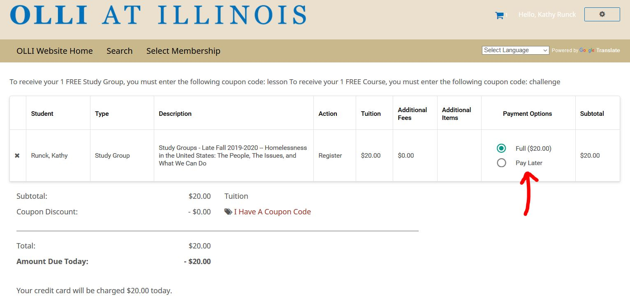

What if I need to drop a course?
We want you to be satisfied with your OLLI activities. If you find that a course does not meet your needs, we will be glad to cancel your registration and either register you for another available option, add a credit to your account, or issue a refund of the fees, based on the policies outlined below.
While we are glad to drop you from a course in accordance with our policies, please do not intentionally over-subscribe to activities with the expectation that you will drop some of them eventually. OLLI staff reserves the right to limit the number of changes or refunds that may be processed for a single member during the membership year.

Course Refund Policy:
To receive a refund, you must contact the OLLI office and formally withdraw from a course no later than 4:00 p.m. on Friday of the first week in which the course meets. After the first week, a student may withdraw from a course, but no refund will be given.
Telephone – (217) 244-9141
Email – olli@illinois.edu

