Books on Turkey and its past that you might like:
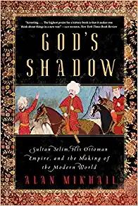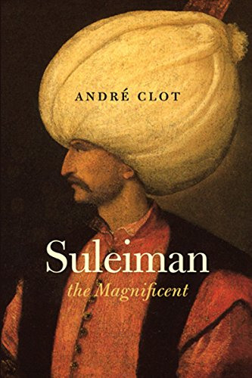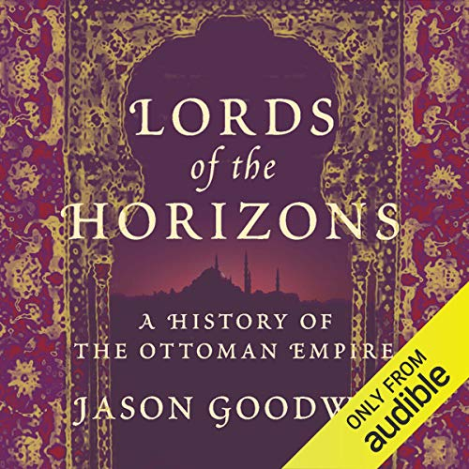
There is 600 years of Ottoman history. You could watch the different Turkish produced-Netflix series on Ertugrul, or Suleiman but they are a bit bloody. Or you can read Bernard Lewis or Halil Incalik for serious details. I liked the above books. The Goodwin is not only in audible.
There is also the ottoman history podcase: Episodes (ottomanhistorypodcast.com)
We didn’t do much with Byzantine Anatolia (because it is not seen as “part of Turkey’s history” by many today) but I recommend Herrin, Byzantium.
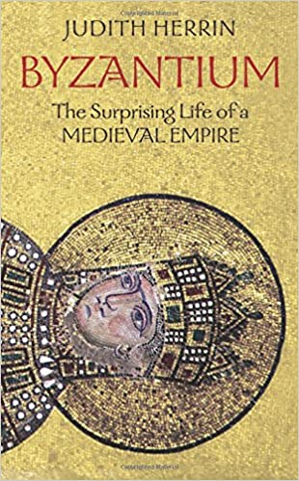

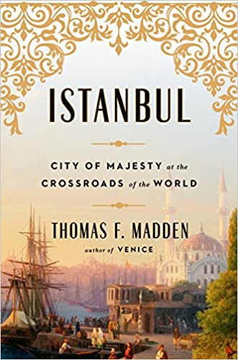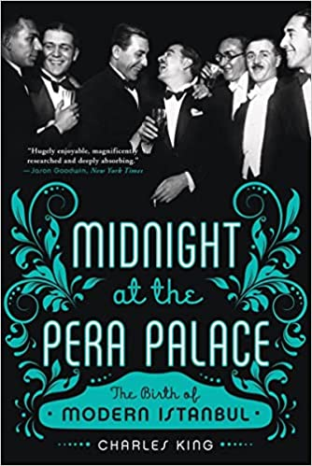
These two are more Istanbul focused.
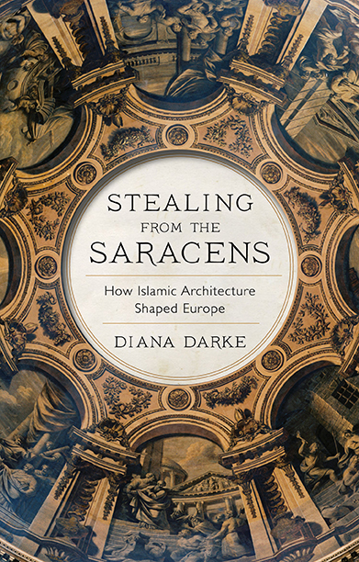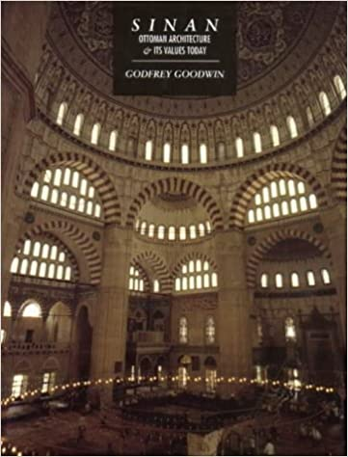
Stealing from the Saracens was a lot of fun, with unexpected explanations of where medieval European Architecture came from. Geoffrey Goodwin’s book on Sinan the Ottoman Architect is also a history of the art of the Empire.

